Improvement vs Improvement Details

What differentiates an “improvement” from an “improvement detail”?
An improvement is just what it sounds like, an improvement on a parcel. A house, a detached garage, a shed, a pool, etc. I think we want pools and swe to be details, not improvements, same with sheds, gazebos. Pole buildings, detached garages, and barns shuld be improvements.
Confirmed with Bill –
Outbuildings that are improvements: Det Gar, Pole Building
Outbuildings that are improvement details: swe, pool, gazebo, hobby, loafing, sheds
An improvement detail is a feature of that given improvement. For example, a 1 story home is an improvement. The attached garage is a detail of that improvement.
The good news is this is a pretty cut and dry classification. The bad news is that in transferring data over to PACS from ProVal, things were often put into the incorrect places. Here’s an example:
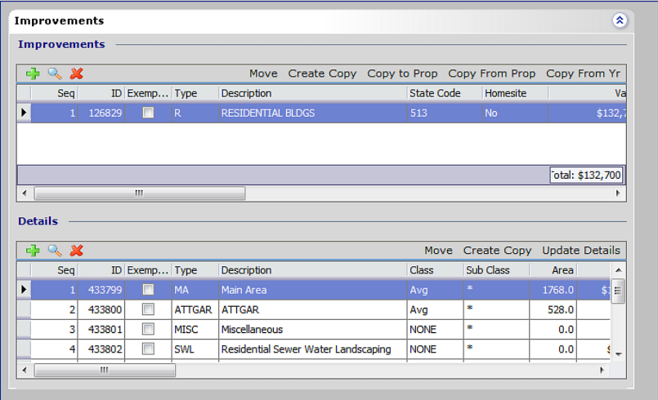
While the home itself is correctly classified as an improvement and the attached garaged is correctly classified as a detail of that improvement, the miscellaneous improvements and residential sewer, water, and landscaping are not actually details. They themselves are improvements and need to be classified as such.
Let’s scroll further down the details list to see what else is in there:
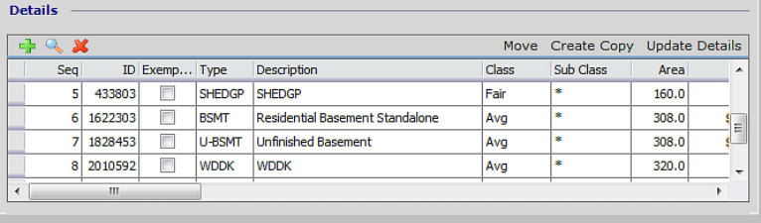

Again, we see a mix of things that are actually details and things that should be their own improvements. The shed, for example, is its own improvement, while the wood deck and basement are correctly placed in the improvement details of the home itself.
We will have to correct these to make sure improvements and details are classified correctly, which means deleting details that are not details and making them standalone improvements. Fortunately we we have all of the information, it just needs to be organized properly.
If you double click (or click on the magnifying glass) on an improvement, it will bring up a pop-up window of that improvement with all of the associated details (again note in this example that some improvements are incorrectly labeled as details):
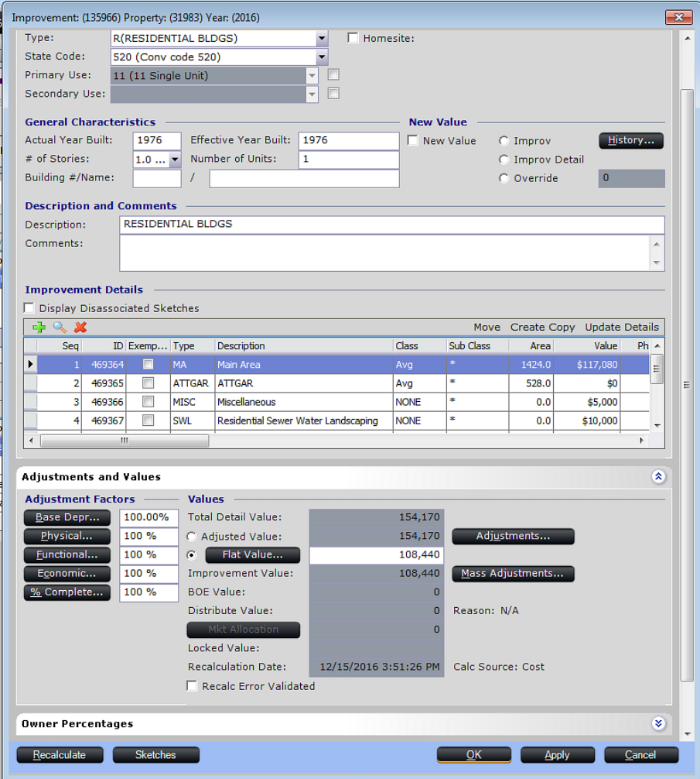
From there you can double click on a detail to bring up the features of that detail, the “details of the detail” if you will:
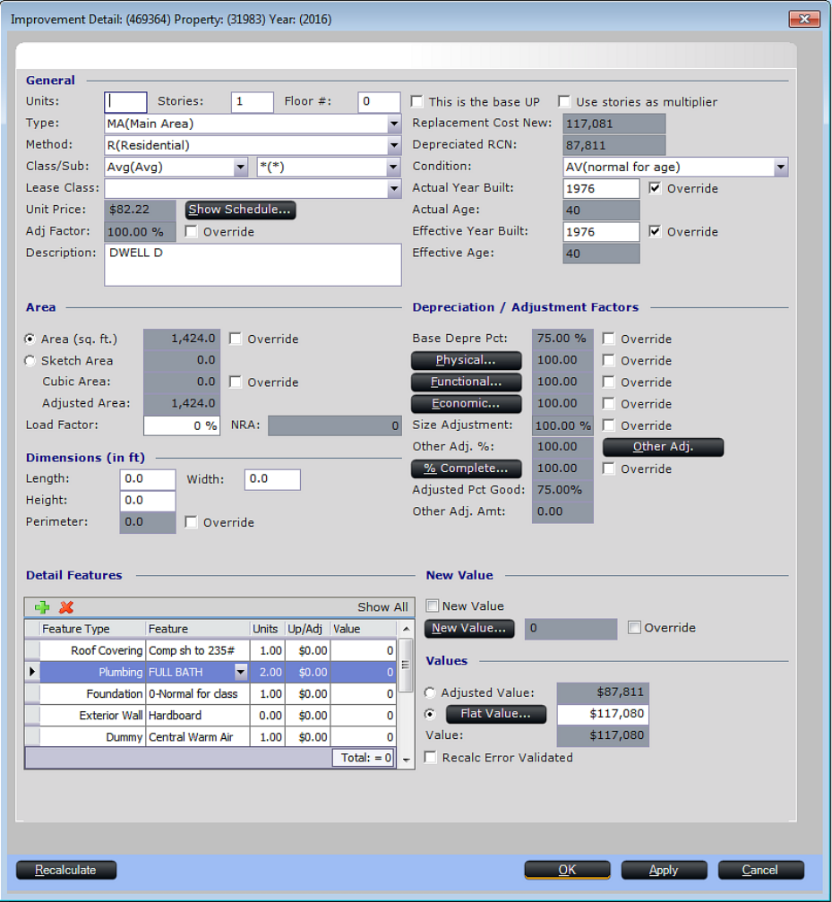
As you can see, this is where you will find items like number of bathrooms, roof and exterior types, foundation, etc.

